

University Of Barishal

**A Research Report On:**

**Factors affecting household of loan amounts.**

**Submitted To:**

Md. Erfan

Assistant Professor

University Of Barishal

Department of Computer Science and Engineering

**Submitted By:**

Shamsunnahar Mim

Department of Economics

Roll: 01-026-20

Submission Date: 05 October, 2024

# Abstract:

In Bangladesh, the amount of a household loan is influenced by several key factors, including occupation,theamountoflandowned,andmonthlyincome.Thesevariablesplayacrucialrolein determiningtheloaneligibilityandamountthatahouseholdcansecurefromfinancialinstitutions. Households with stable and higher monthly incomes, larger land holdings, and more secure occupations are generally more likely to qualify for larger loan amounts.Understanding the interplay of these factors is essential for both borrowers and lenders in the Bangladeshi context.Thisresearchseekstocontributetoamorecomprehensiveunderstandingofthedynamics ofhouseholdloansinBangladesh,ultimatelypromotingfinancialinclusionandeconomicstability in the region.To examine the relationship between &s

occupation and household loan amounts in Bangladesh, identifying which occupations are more likelytosecurelargerloansandalso.Thisresearchemploysamixed-methodapproach,combining data collected from both online and offline sources. Offline data will be collected through interviews with individuals residing in different villages across Bangladesh. This comprehensive methodology will provide a well-rounded perspective on the complex factors influencing household loan amounts in BangladeshThe findings of this research reveal that occupation, land ownership, and monthly income play significant roles in determining household loan amounts in Bangladesh. Certain occupations, particularly those with more stable and higher incomes, are associated with greater loan accessibility. Land ownership, especially in rural areas, is positively correlated with loan eligibility. Monthly income levels were found to be a crucial determinant, withspecificincomethresholdssignificantlyimpactingloanaccessibility.Thesignificanceofthis research lies in its potential to inform policymakers, financial institutions, and households in Bangladesh. It offers insights into the factors that influence loan accessibility, empowering stakeholders to develop more inclusive financial practices. By understanding the implications of thesefindings,policymakerscandesignmoretargetedfinancialinclusionstrategies,andfinancial institutions can tailor their lending practices to better serve the diverse needs of the population. Moreover, households can use this knowledge to optimize their financial prospects and improve their economic well-being, ultimately contributing to the growth and stability of the natio

**Keywords:**Ruralvs.urbanborrowers,incomelevels,totalamountoflandinthehousehold,interest rate,household size.

# Introduction:

Bangladesh, a densely populated country in South Asia, has witnessed a significant proliferation ofmicrofinanceinstitutionsandaremarkableexpansionoffinancialservicesaimedathouseholds. Thisfinanciallandscapehasledtoanintricaterelationshipbetweenhouseholdsandloanamounts. Understandingthefactorsthatinfluencetheloanamountssoughtandobtainedbyhouseholdsin

Bangladesh is of paramount importance, as it not only impacts the economic well-being of individual families but also has broader implications for the nation's economic growth and development.MicrocreditinstitutionslikeGrameen Bankand BRAChaveplayed apivotalrolein providingfinancialaccesstotheunbankedandunderprivilegedsegmentsofsociety.Inthiscontext, investigating the factors affecting household loan amounts becomes crucial, as it sheds light on the dynamics of microfinance in the country.This research paper aims to delve into the multifaceteddeterminantsofhouseholdloanamountsinBangladesh.Itwillexplorevariousfactors that influence borrowing decisions, including but not limited to income levels, interest rates, borrower demographics, collateral requirements, and cultural influences. By examining these factors, this study seeks to provide a comprehensive understanding of the borrowing behavior of households in Bangladesh and contribute to the ongoing discourse on financial inclusion and microcreditin thecountry.Thesubsequentsectionsofthispaperwillanalyzeeachof thesefactors in detail, drawing from empirical data, case studies, and existing literature to elucidate their roles in shaping household loanamounts.

# LITERATUREREVIEW:

The starting point in analysing credit demand and access is the “life cycle model” (Modigliani, 1966).Thelife-cyclehypothesis(arguesthatconsumersinter-temporallyreallocatetheirincomes (resources)overtheirlifetimetomaximizelifetimeutility,subjecttobudgetconstraint(Morduch, 1995).Therefore,consumers cansmoothconsumptionand/orincreaseutilitybyaccessingcredit, ascreditimprovesconsumers’purchasing power.Credithelpsindividualsorhouseholds tomake inter-temporalchoiceandservesasadditionalspendingpowerinthepresentinexchangeforfuture repayment in the form of the loan plus interest (Soman and Cheema, 2002). On the contrary, the “permanentincomehypothesis”arguesthatconsumers’currentconsumptiondependsonexpected consumption in the future period. That is consumers first estimate their ability to consume in the longrunandthensetcurrentconsumptiontotheappropriatefractionofthatestimate,butthelater depends on individuals characteristics (Hall, 1978).

Determinants of households demand for credit has been explored extensively in the literature, however, each of these studies differs in its underlying objective, model(s) and variables used. Most of these studies focused on borrowers’ personal characteristics or attributes. Miller and Ladman (1983), applied discriminant analysis to identify a set of socio-economic, physical and psychological factors that influence credit use among peasant farmers in Bolivia with the view to differentiate between borrowers, potential borrowers, and non-borrowers. The results indicated that borrowers were characterized by higher resource base, farm size, higher level of education, large number of cattle, higher household incomes, higher level of market integration, greater use of improved technology, larger operating costs and investments, and higher risk ability among others.Ontheotherhand,potentialborrowerswerecharacterizedbyfurtherdistancefrommarkets, low level of market integration, higher transaction costs, less number of cattle, etc. Furthermore, non-potential borrowers were characterized by lack of interest to expand production, lower level of education, limited use of improved technology, shortage of labor and proximity to market.

AccordingtoPittandKhandker(2002)andMorduch(1999),participationincreditprogrammeor loan size is determined by household characteristics such as gender of household head, age of household head, number of household members, education level of household head, agricultural work, value of house and land holding size; and of commune characteristics including distance fromthecommunitytothenearestgovernmentbanksanddistancefromcommunitytothenearest bank.

StudiesfromVietnamshowthatcharacteristicsoftheruralhouseholdhead,householdexpenditure and asset significantly influence both the probability of borrowing and loan size. The probability of borrowing increases with education and social responsibility of the household heads. Age negatively influences the probability of borrowing, but it has a positive effect on loan size. Household size has a negative effect on the probability to borrow as well as on the amount borrowed (Ha, 1999; Ha, 2001).

A study by Pal (2002) revealed that more land holdings and less labour income significantly increase the probability of using formal loan, but the opposite relationship does not hold in the case of informal loans. Research by Barslund and Tarp (2008), found countervailing impacts of education, number of dependents, assets, credit history and secure land rights on the demand for formal and informal credit. However, most of the variables mentioned above with the exception of assets had a significant effect only on either formal or informal credit source. Connections to credit institutions had a positive significant impact on the demand for both formal and informal loans. Their analysis suggests that demand for formal loans is largely influenced by factors such as land holdings, and hence geared towards production purposes and asset management, whereas informal credit demand is negatively influenced by age and education, and positively associated with a bad credit history and number of dependents. This indicates household’s tendency to use informal loans for consumption smoothing rather than investment.

# Methodology:

Designing a research methodology for factors affecting household loan amounts in Bangladesh would involve several key components. Here's a basic outline of the methodology:

# ResearchObjectives:

Clearlydefinetheresearchobjectives.WhatspecificaspectsofhouseholdloansinBangladeshare you trying to investigate? For example, you might want to understand factors influencing loan approval amounts or factors affecting loan repayment amounts.

# Data Collection:

1. DataSources:Identifythesourcesofdata.InBangladesh,youmightaccessdatafromfinancial institutions, government records, surveys, and academic studies.
2. Sampling:Defineyoursamplingstrategy.Areyouconductingarandomsampleorusinga specific population subset?
3. DataCollectionMethods:Specifyhowyou'llcollectdata,suchassurveys,interviews,or analyzing pre-existing datasets.

# Variables:

1. DependentVariable:Definetheprimaryvariableofinterest(e.g.,householdloanamounts).
2. Independent Variables: Identify the factors you believe influence the dependent variable (e.g., income, credit history, loan interest rates).

# Data Analysis:

1. **Statistical Methods:** Choose the appropriate statistical tools for analyzing the data. Common techniques include regression analysis, correlation, and descriptive statistics.
2. **Software**:Specifythestatisticalsoftwareyouplantouse(e.g.,SPSS,R,Python).

# Findings:

## Figure1:HouseholdheadsAge:

The age of 52 was 10% of people. And the data collected was the highest age of 62 people.The youngest person was 21 years old.Loan amount of the household heads depends on age.

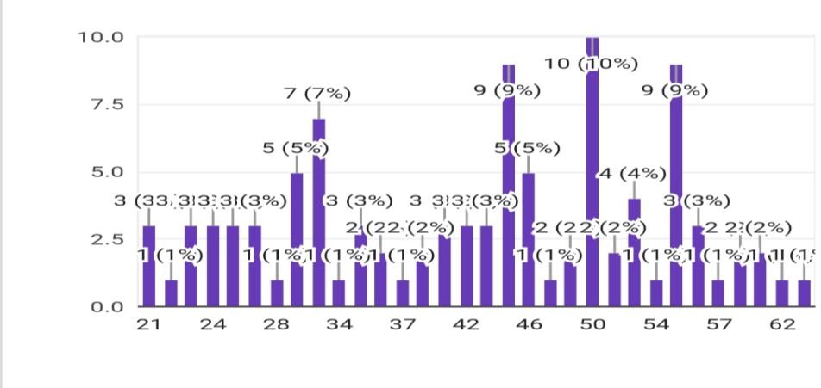

## Figure2:MonthlyIncome

Highestmontlyincomeofthehouseholdis50,000taka,and.lowestincomeofthehouseholdis

4000 taka.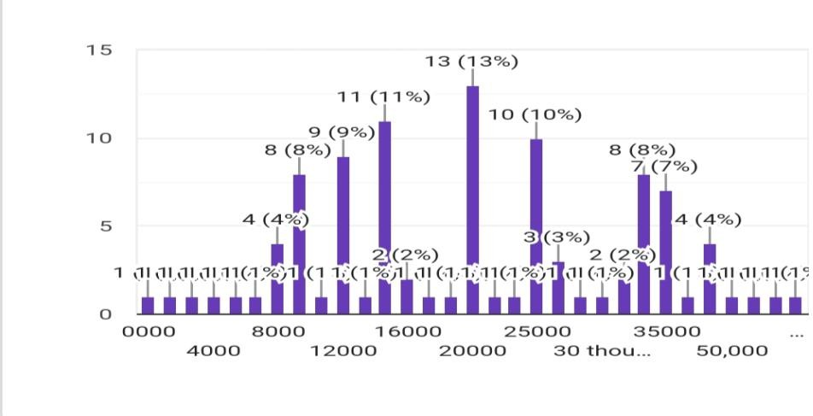

## Figure3:typeof tenancyoccupied by yourdwelling households

In Bangladesh, the type of tenancy can significantly affect the household loan amount. Based on the data you provided, here are some factors to consider:As I mentioned, 83% of households in Bangladesh own their homes. Homeownership typically reduces the need for housing loans, as homeowner.The15%ofhouseholdswhoarerentersmayhaveahigherdemandforhousingloans. They may require loans for security deposits, monthly rent payments, or other financial needs related to their housing situation.

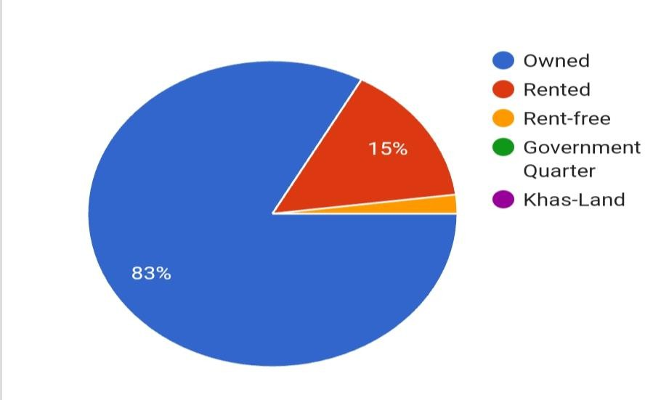

## Figure4:Savingacountoremergencyfund

86%householdshavesavingsoremergencyfundand14%havenosavingsaccountoremergency fund.

**Figure5:Regression Model**

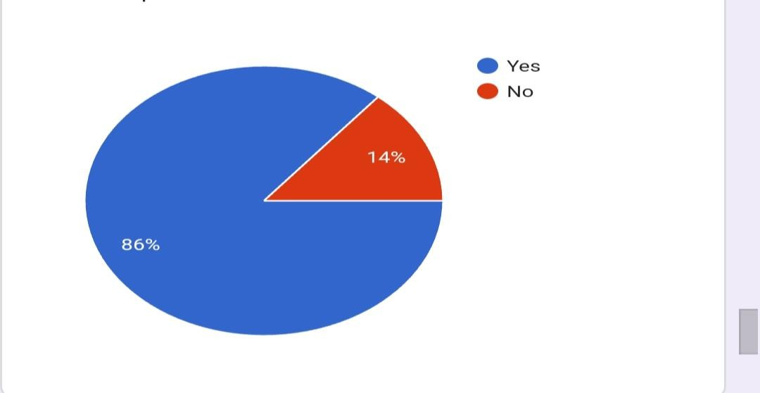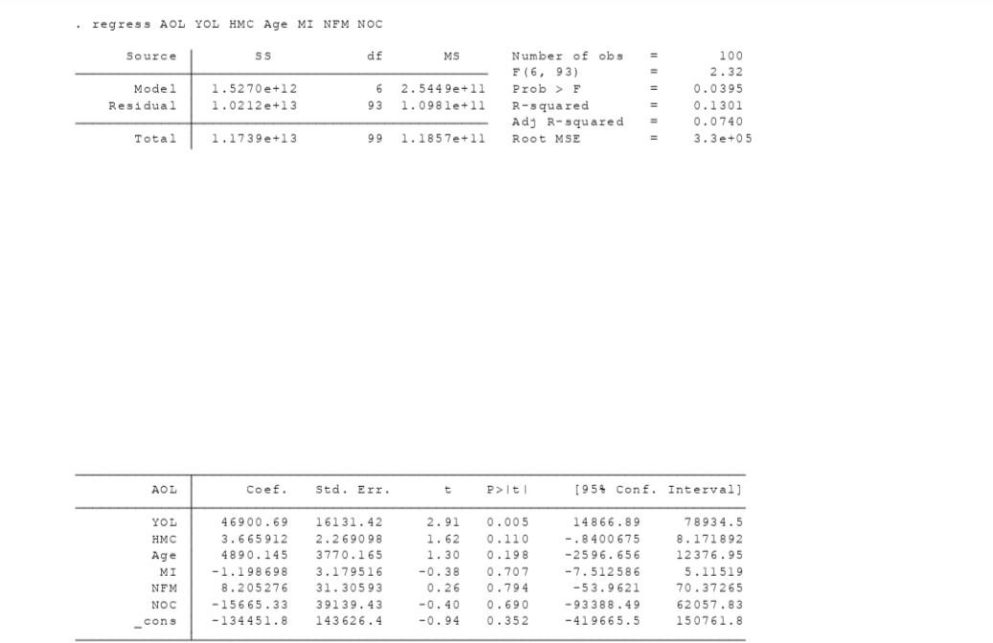

# Conclusion:

In the conclusion section, you can summarize the key findings of your research. For instance:HighlightthemostsignificantfactorsaffectingloanamountsinBangladeshihouseholds.

Discussanyunexpectedornoteworthy findings.

Emphasizetheimportanceofunderstandingthesefactors forpolicymakers,financialinstitutions, and individuals.

# Recommendations:

Providesuggestions based on your research findings. Thesemightinclude:Recommendations for policymakerstoaddressissuesrelatedtoloanaccessorfinancialliteracy.Suggestionsforfinancial institutions totailortheir loanofferings.Guidanceforhouseholds onmanagingtheirfinances and making informed borrowing decisions.

# Limitations:

Acknowledgethelimitationsofyourresearch,suchas:Datalimitations,ifany.Constraintsonthe scope of the research.Potential biases in the data or methodology.Any external factors that could haveinfluencedtheresults.Remembertosupportyourconclusionsandrecommendationswiththe data and findings from your research.

# Reference

Adams,D.W.,Graham,D.W.,VonPischke,J.D.(1984),Undermining Rural Development with Cheap Credit. Boulder. Colorado: Westveiw

Press.Adams, D.W., Vogel, C.R. (1985), Rural credit market in low income countries: Recent controversies and lessons. World Development,14(4), 477-487.

Amin, S., Rai, A.S., Topa, G. (2003), Does microcredit reach the poor and vulnerable? Evidence from northern bangladesh. Journal of Development Economics, 70(1), 59-82.

Anyiro, C.O., Oriaku, B.N. (2011), Access to and investment of formal micro credit by small holder farmers in Abia State, Nigeria. A case study of Absu Micro Finance Bank, Uturu. Agricultural Economics, 6(2) 70-76.